**Notes on routing protocols**

Routing is at the core of every data network, moving information across an internetwork from source to destination. Routers are the devices responsible for the transfer of packets from one network to the next.

Routers learn about remote networks either dynamically, using routing protocols, or manually, or using static routes. In many cases, routers use a combination of both dynamic routing protocols and static routes. This chapter focuses on static routing.

Static routes are very common and do not require the same amount of processing and overhead as dynamic routing protocols.

Router can learn about remote networks in one of two ways:

* **Manually** - Remote networks are manually entered into the route table using static routes.
* **Dynamically** - Remote routes are automatically learned using a dynamic routing protocol

**Static routing provides some advantages over dynamic routing, including:**

* Static routes are not advertised over the network, resulting in better security.
* Static routes use less bandwidth than dynamic routing protocols, no CPU cycles are used to calculate and communicate routes.
* The path a static route uses to send data is known.

**Static routing has the following disadvantages:**

* Initial configuration and maintenance is time-consuming.
* Configuration is error-prone, especially in large networks.
* Administrator intervention is required to maintain changing route information.
* Does not scale well with growing networks; maintenance becomes cumbersome.
* Requires complete knowledge of the whole network for proper implementation.

**Types of Static Routes**

* **Standard static route**

Static routes are useful when connecting to a specific remote network.

The figure shows that R2 can be configured with a static route to reach the stub network 172.16.3.0/24.

**Note**: The example is highlighting a stub network, but in fact, a static route can be used to connect to any network.

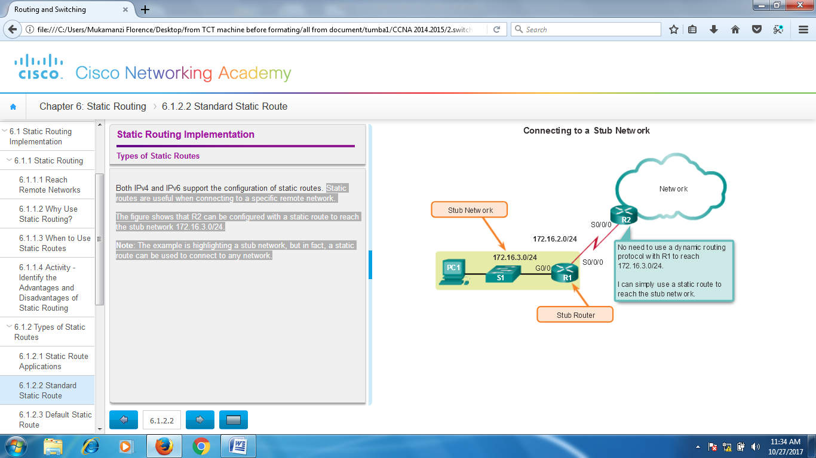

**Default** **static** **route**

All routes that identify a specific destination with a larger subnet mask take precedence over the default route.

**Default static routes are used:**

* When no other routes in the routing table match the packet destination IP address. In other words, when a more specific match does not exist. A common use is when connecting a company's edge router to the ISP network.
* When a router has only one other router to which it is connected. This condition is known as a stub router

**Summary static route**

To reduce the number of routing table entries, multiple static routes can be summarized into a single static route if:

* The destination networks are contiguous and can be summarized into a single network address.
* The multiple static routes all use the same exit interface or next-hop IP address.

In the figure, R1 would require four separate static routes to reach the 172.20.0.0/16 to 172.23.0.0/16 networks. Instead, one summary static route can be configured and still provide connectivity to those networks.

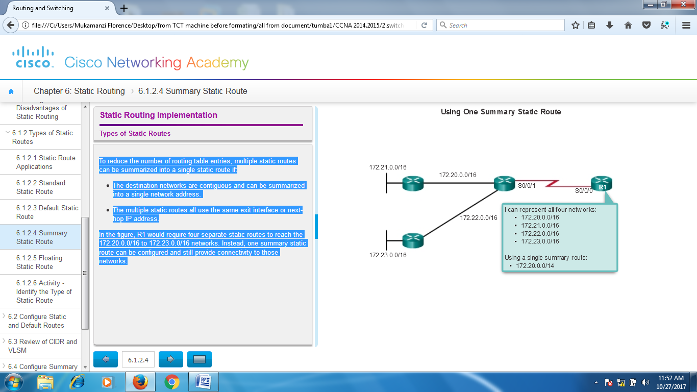

**Floating static route**

Another type of static route is a floating static route. Floating static routes are static routes that are used to provide a backup path to a primary static or dynamic route, in the event of a link failure. The floating static route is only used when the primary route is not available.

To accomplish this, the floating static route is configured with a higher administrative distance than the primary route

The administrative distance represents the trustworthiness of a route. If multiple paths to the destination exist, the router will choose the path with the lowest administrative distance

For example, assume that an administrator wants to create a floating static route as a backup to an EIGRP-learned route. The floating static route must be configured with a higher administrative distance than EIGRP. EIGRP has an administrative distance of 90. If the floating static route is configured with an administrative distance of 95, the dynamic route learned through EIGRP is preferred to the floating static route. If the EIGRP-learned route is lost, the floating static route is used in its place.

In the figure, the Branch router typically forwards all traffic to the HQ router over the private WAN link. In this example, the routers exchange route information using EIGRP. A floating static route, with an administrative distance of 91 or higher, could be configured to serve as a backup route. If the private WAN link fails and the EIGRP route disappears from the routing table, the router selects the floating static route as the best path to reach the HQ LAN.

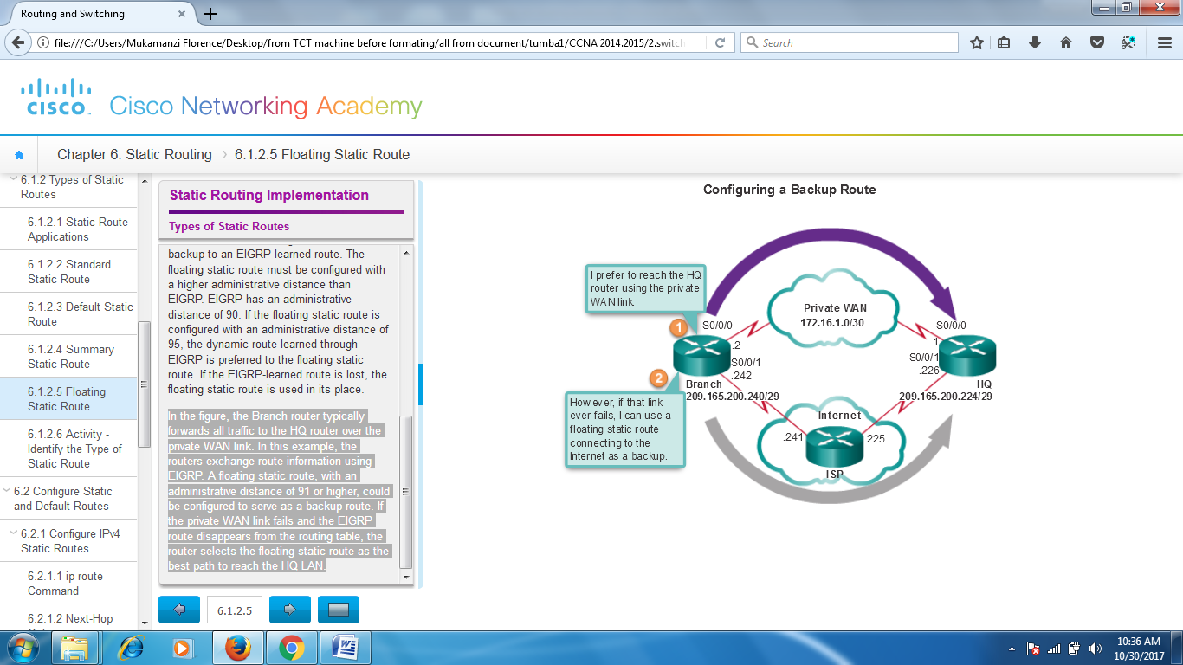

# Configure Static and Default Routes

Static routes are configured using the **ip route** global configuration command. The syntax of the command is:

Router(config)# **ip route** *network-address subnet-mask* { *ip-address* | *interface-type interface-number* [ *ip-address* ]} [ *distance* ] [ **name** *name* ] [ **permanent** ] [ **tag** *tag* ]

The following parameters are required to configure static routing:

* *network-address* - Destination network address of the remote network to be added to the routing table, often this is referred to as the prefix.
* *subnet-mask* - Subnet mask, or just mask, of the remote network to be added to the routing table. The subnet mask can be modified to summarize a group of networks.

One or both of the following parameters must also be used:

* *ip-address* - The IP address of the connecting router to use to forward the packet to the remote destination network. Commonly referred to as the next hop.
* *exit-intf* - The outgoing interface to use to forward the packet to the next hop.

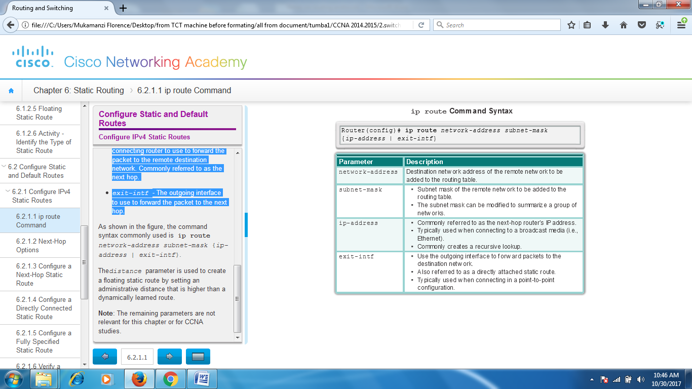

In this example, Figures 1 to 3 display the routing tables of R1, R2, and R3. Notice that each router has entries only for directly connected networks and their associated local addresses. None of the routers have any knowledge of any networks beyond their directly connected interfaces.

For example, R1 has no knowledge of networks:

* 172.16.1.0/24 - LAN on R2
* 192.168.1.0/24 - Serial network between R2 and R3
* 192.168.2.0/24 - LAN on R3

Figure 4 displays a successful ping from R1 to R2. Figure 5 displays an unsuccessful ping to the R3 LAN. This is because R1 does not have an entry in its routing table for the R3 LAN network.

The next hop can be identified by an IP address, exit interface, or both. How the destination is specified creates one of the three following route types:

* **Next-hop route** - Only the next-hop IP address is specified.
* **Directly connected static route** - Only the router exit interface is specified.
* **Fully specified static route** - The next-hop IP address and exit interface are specified.

**Figure1.**

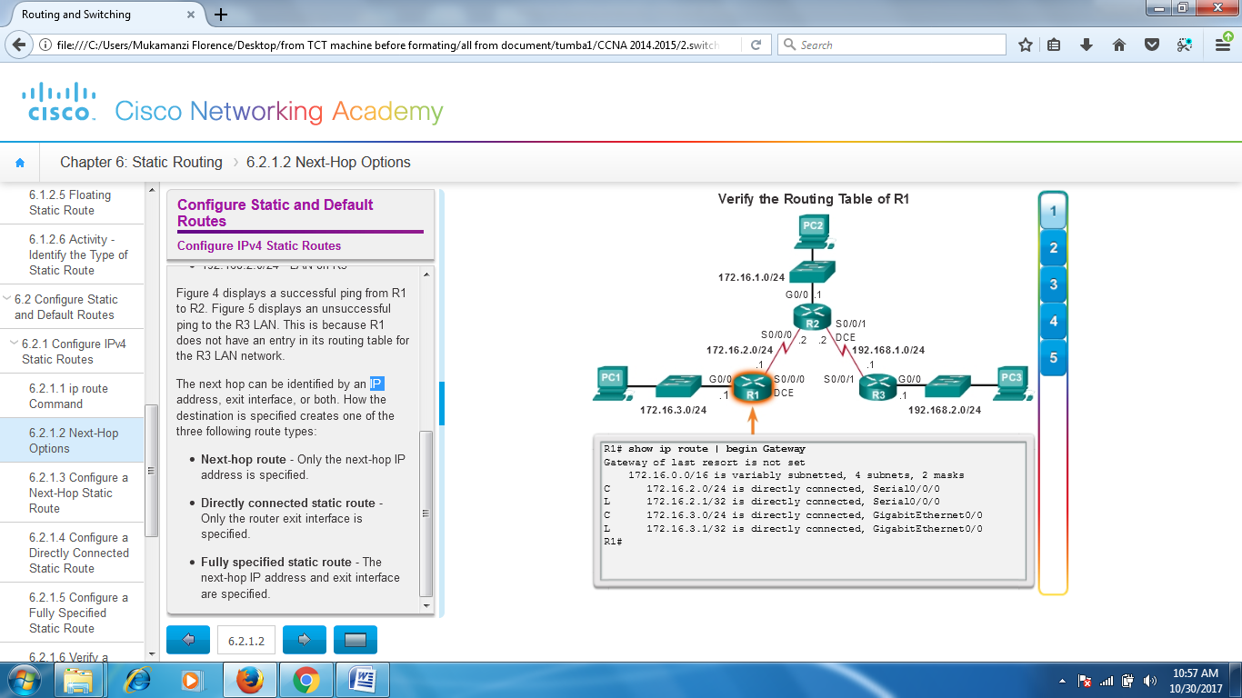

**Figure 2**

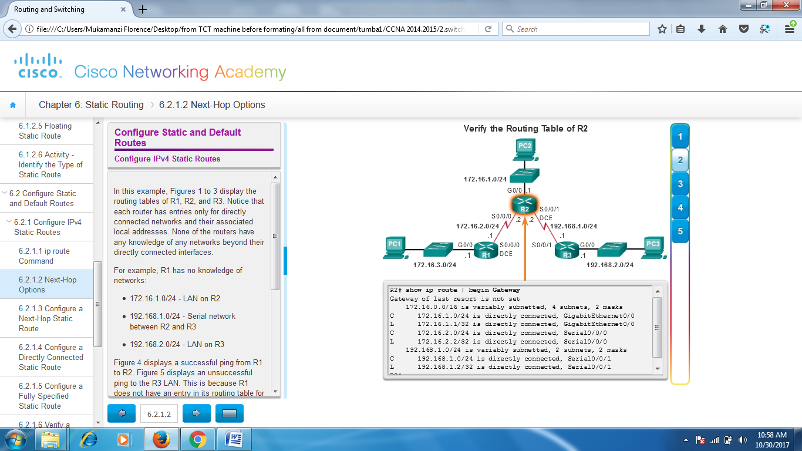

**Figure3**

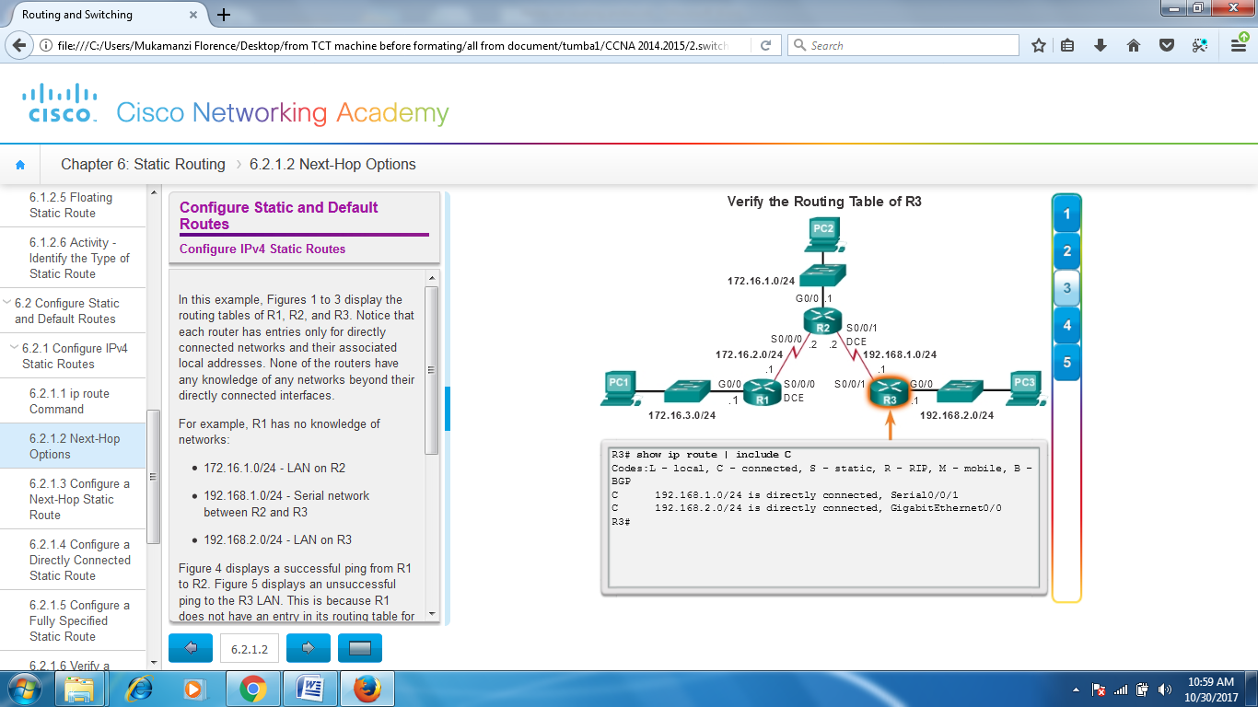

**Figure 4**

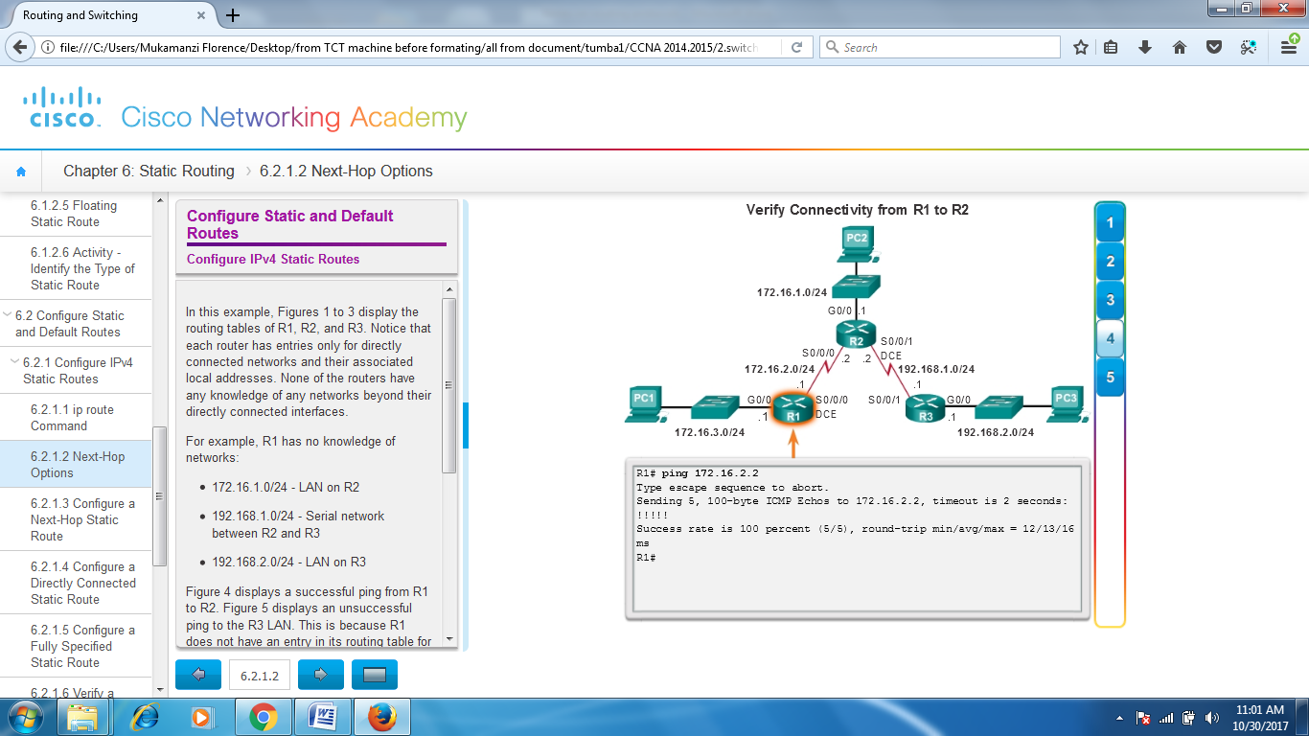

**Figure 5**

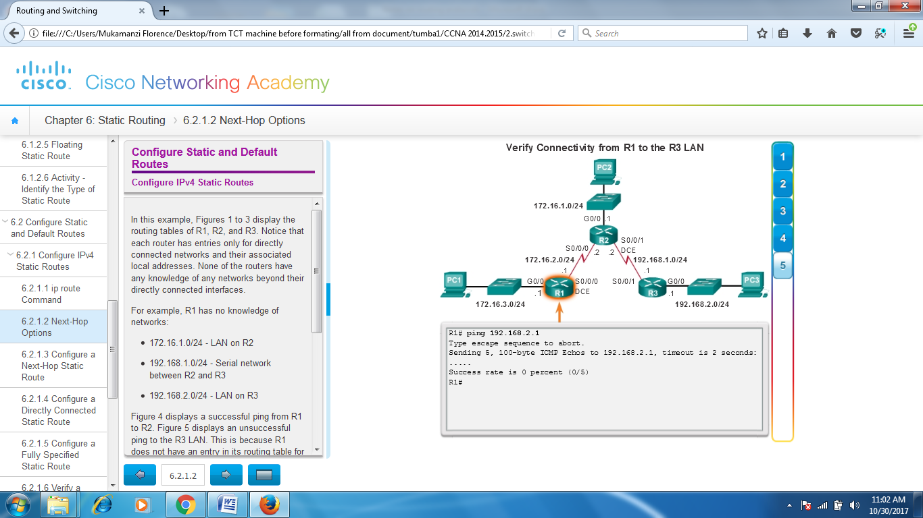

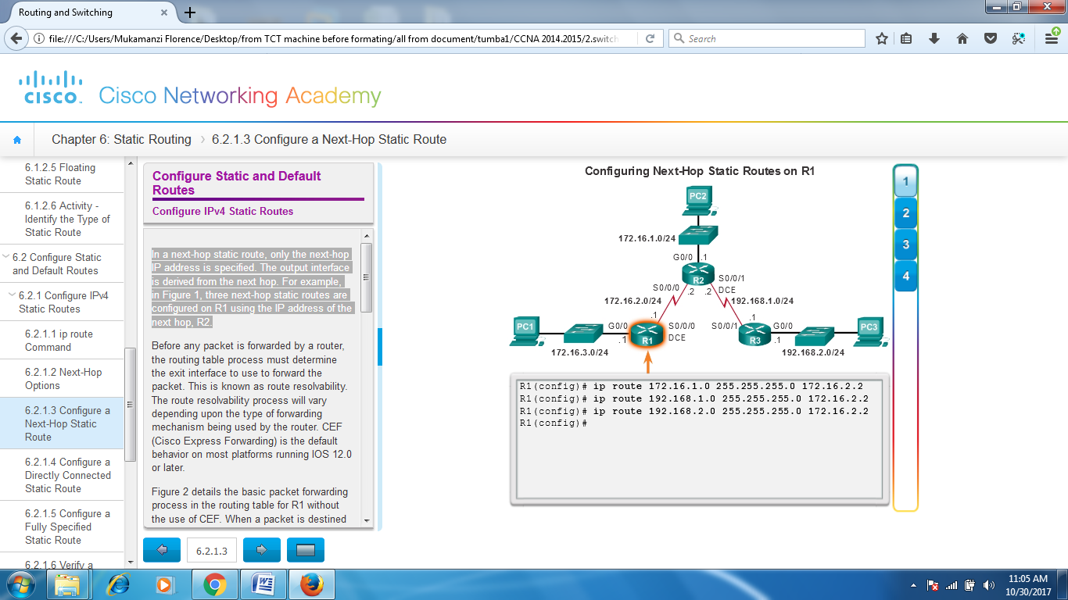

In a next-hop static route, only the next-hop IP address is specified. The output interface is derived from the next hop. For example, in Figure 1, three next-hop static routes are configured on R1 using the IP address of the next hop, R2.

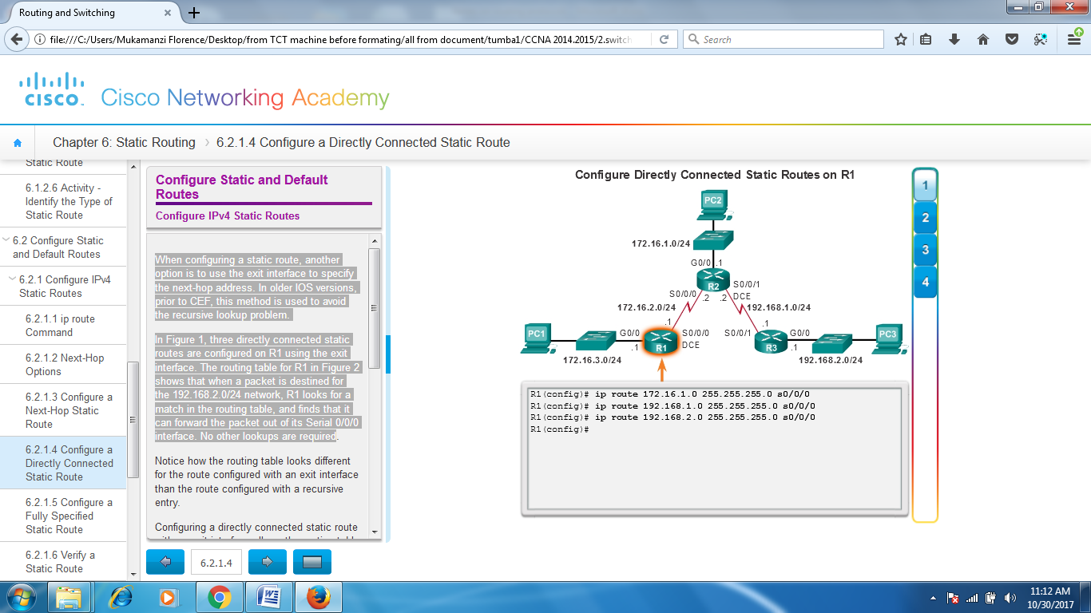

When configuring a static route, another option is to use the exit interface to specify the next-hop address. In older IOS versions, prior to CEF, this method is used to avoid the recursive lookup problem.

In Figure 1, three directly connected static routes are configured on R1 using the exit interface. The routing table for R1 in Figure 2 shows that when a packet is destined for the 192.168.2.0/24 network, R1 looks for a match in the routing table, and finds that it can forward the packet out of its Serial 0/0/0 interface. No other lookups are required

## Configure IPv4 Default Routes

A default route is a static route that matches all packets. Rather than storing all routes to all networks in the routing table, a router can store a single default route to represent any network that is not in the routing table.

Routers commonly use default routes that are either configured locally or learned from another router, using a dynamic routing protocol. A default route is used when no other routes in the routing table match the destination IP address of the packet. In other words, if a more specific match does not exist, then the default route is used as the Gateway of Last Resort.

Default static routes are commonly used when connecting:

* An edge router to a service provider network
* A stub router (a router with only one upstream neighbor router)

As shown in the figure, the command syntax for a default static route is similar to any other static route, except that the network address is **0.0.0.0** and the subnet mask is **0.0.0.0**. The basic command syntax of a default static route is:

* **ip route 0.0.0.0 0.0.0.0** { *ip-address* | *exit-intf* }

**Note**: An IPv4 default static route is commonly referred to as a quad-zero route.

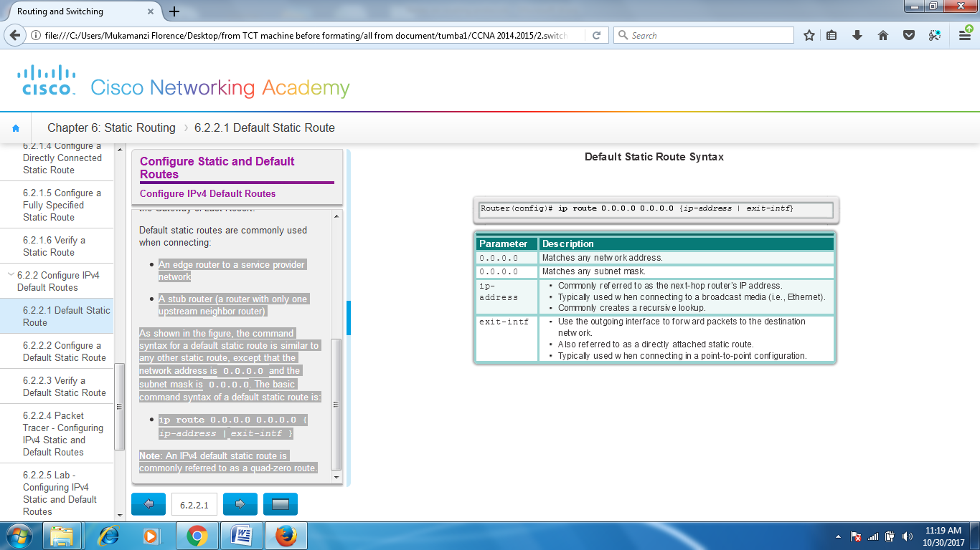

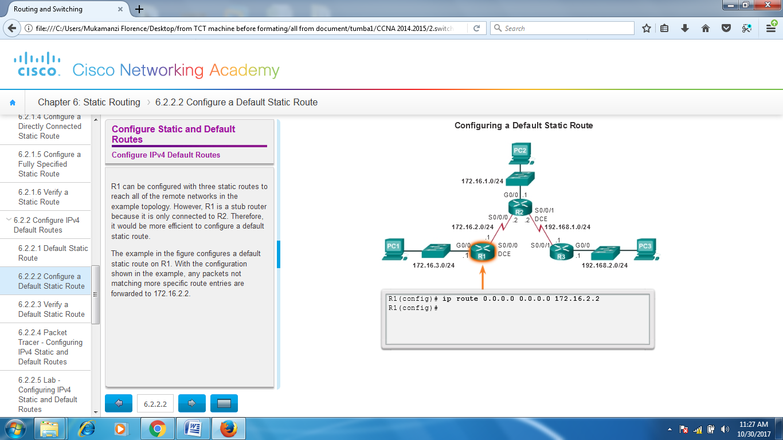

**ROUTING DYNAMICALLY**

The data networks that we use in our everyday lives to learn, play, and work range from small, local networks to large, global internetworks. At home, a user may have a router and two or more computers. At work, an organization may have multiple routers and switches servicing the data communication needs of hundreds or even thousands of PCs.

Routers forward packets by using information in the routing table. Routes to remote networks can be learned by the router in two ways: static routes and dynamic routes.

In a large network with numerous networks and subnets, configuring and maintaining static routes between these networks requires a great deal of administrative and operational overhead. This operational overhead is especially cumbersome when changes to the network occur, such as a down link or implementing a new subnet. Implementing dynamic routing protocols can ease the burden of configuration and maintenance tasks and give the network scalability

Dynamic routing protocols have been used in networks since the late 1980s. One of the first routing protocols was Routing Information Protocol (RIP). RIP version 1 (RIPv1) was released in 1988, but some of the basic algorithms within the protocol were used on the Advanced Research Projects Agency Network (ARPANET) as early as 1969.

As networks evolved and became more complex, new routing protocols emerged. The RIP routing protocol was updated to accommodate growth in the network environment, into RIPv2. However, the newer version of RIP still does not scale to the larger network implementations of today. To address the needs of larger networks, two advanced routing protocols were developed: Open Shortest Path First (OSPF) and Intermediate System-to-Intermediate System (IS-IS). Cisco developed the Interior Gateway Routing Protocol (IGRP) and Enhanced IGRP (EIGRP), which also scales well in larger network implementations.

Additionally, there was the need to connect different internetworks and provide routing between them. The Border Gateway Protocol (BGP) is now used between Internet service providers (ISPs). BGP is also used between ISPs and their larger private clients to exchange routing information.

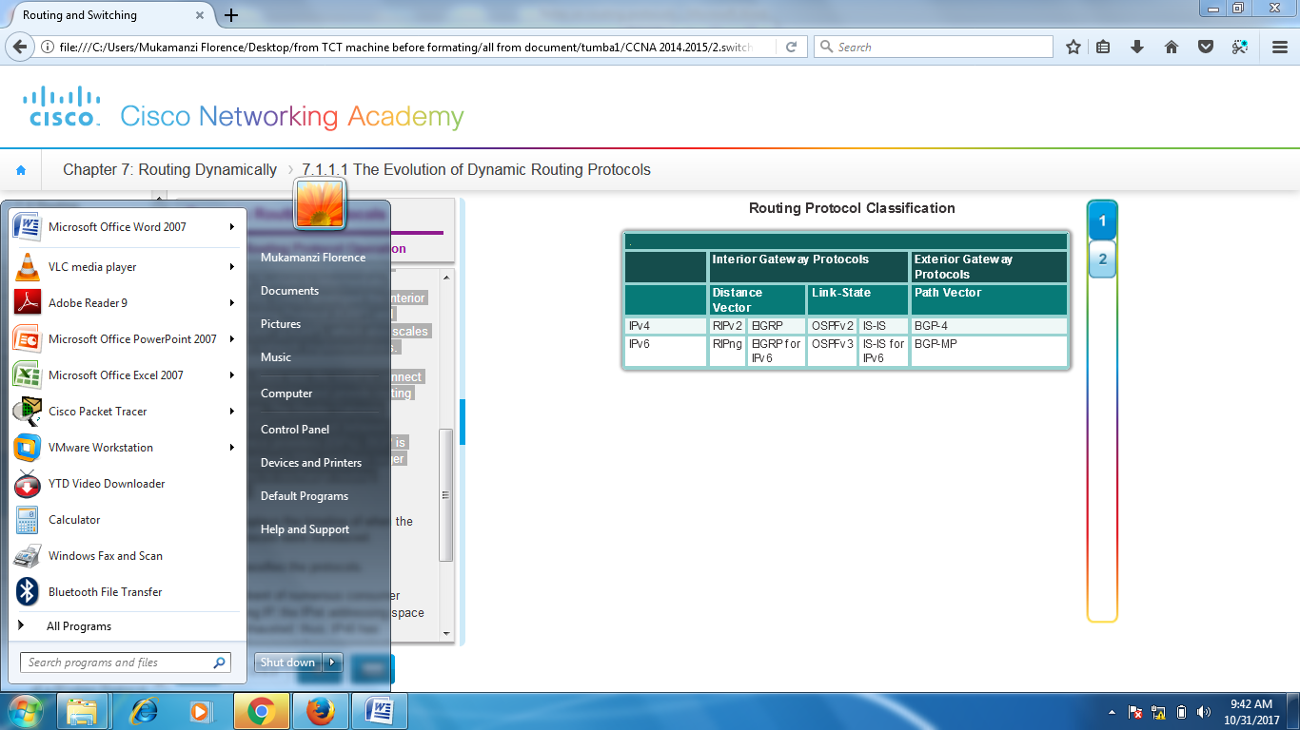

**Dynamic Routing Protocol Operation**

Routing protocols are used to facilitate the exchange of routing information between routers. A routing protocol is a set of processes, algorithms, and messages that are used to exchange routing information and populate the routing table with the routing protocol's choice of best paths. The purpose of dynamic routing protocols includes:

* Discovery of remote networks
* Maintaining up-to-date routing information
* Choosing the best path to destination networks
* Ability to find a new best path if the current path is no longer available

The main components of dynamic routing protocols include:

* **Data structures -** Routing protocols typically use tables or databases for its operations. This information is kept in RAM.
* **Routing protocol messages -** Routing protocols use various types of messages to discover neighboring routers, exchange routing information, and other tasks to learn and maintain accurate information about the network.
* **Algorithm -** An algorithm is a finite list of steps used to accomplish a task. Routing protocols use algorithms for facilitating routing information and for best path determination.

The figure highlights the data structures, routing protocol messages, and routing algorithm used by EIGRP.

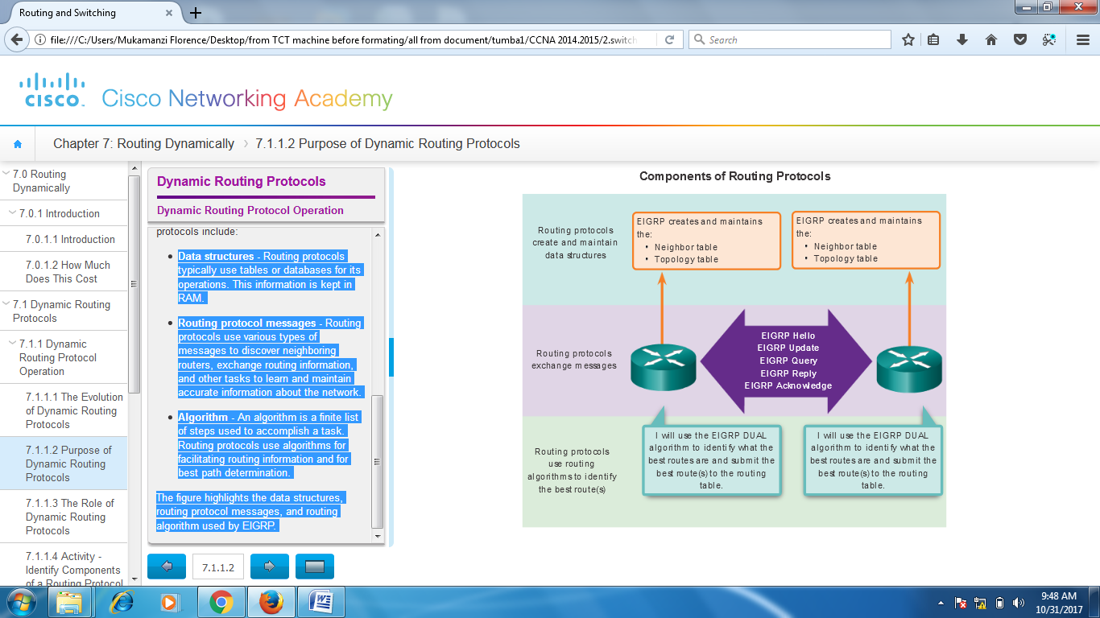

Routing protocols allow routers to dynamically share information about remote networks and automatically add this information to their own routing tables; see the animation in the figure.

Routing protocols determine the best path, or route, to each network. That route is then added to the routing table. A primary benefit of dynamic routing protocols is that routers exchange routing information when there is a topology change. This exchange allows routers to automatically learn about new networks and also to find alternate paths when there is a link failure to a current network.

Compared to static routing, dynamic routing protocols require less administrative overhead. However, the expense of using dynamic routing protocols is dedicating part of a router’s resources for protocol operation, including CPU time and network link bandwidth. Despite the benefits of dynamic routing, static routing still has its place. There are times when static routing is more appropriate and other times when dynamic routing is the better choice. Networks with moderate levels of complexity may have both static and dynamic routing configured.

**Dynamic versus Static Routing**

Before identifying the benefits of dynamic routing protocols, consider the reasons why network professionals use static routing. Dynamic routing certainly has several advantages over static routing; however, static routing is still used in networks today. In fact, networks typically use a combination of both static and dynamic routing.

Static routing has several primary uses, including:

* Providing ease of routing table maintenance in smaller networks that are not expected to grow significantly.
* Routing to and from a stub network, which is a network with only one default route out and no knowledge of any remote networks.
* Accessing a single default route (which is used to represent a path to any network that does not have a more specific match with another route in the routing table).

The figure provides a sample scenario of static routing.

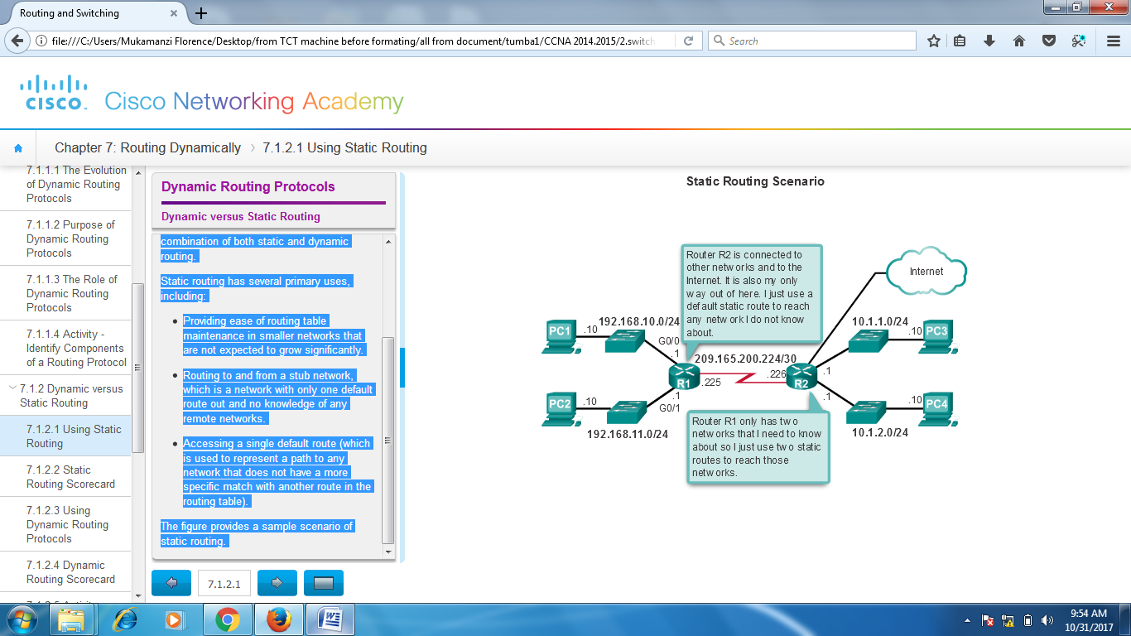

The table in the figure highlights the advantages and disadvantages of static routing. Static routing is easy to implement in a small network. Static routes stay the same, which makes them fairly easy to troubleshoot. Static routes do not send update messages and, therefore, require very little overhead.

**The disadvantages of static routing include:**

* They are not easy to implement in a large network.
* Managing the static configurations can become time consuming.
* If a link fails, a static route cannot reroute traffic.

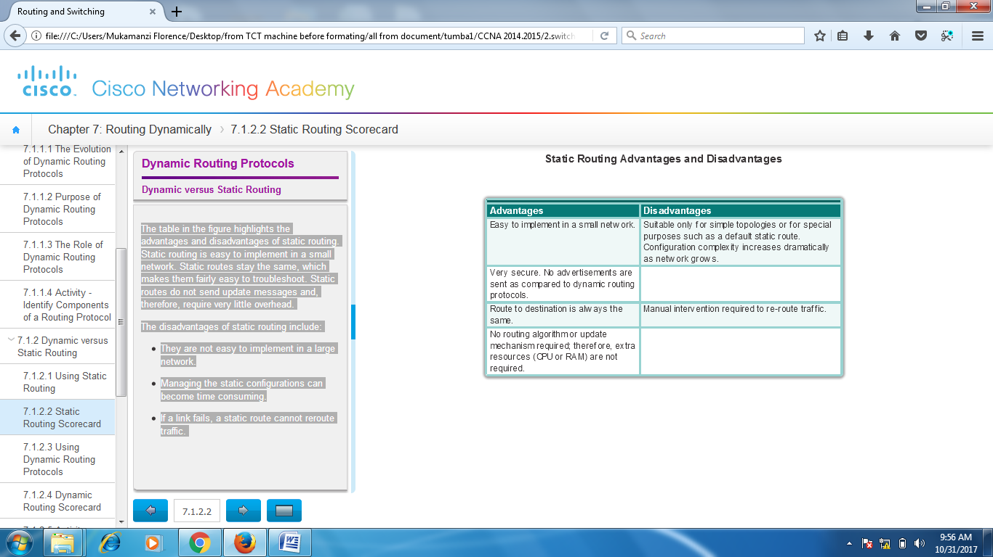

**Dynamic routing protocols** help the network administrator manage the time-consuming and exacting process of configuring and maintaining static routes.

Imagine maintaining the static routing configurations for the seven routers in Figure 1.

What if the company grew and now had four regions and 28 routers to manage, as shown in Figure 2? What happens when a link goes down? How do you ensure that redundant paths are available?

Dynamic routing is the best choice for large networks like the one shown

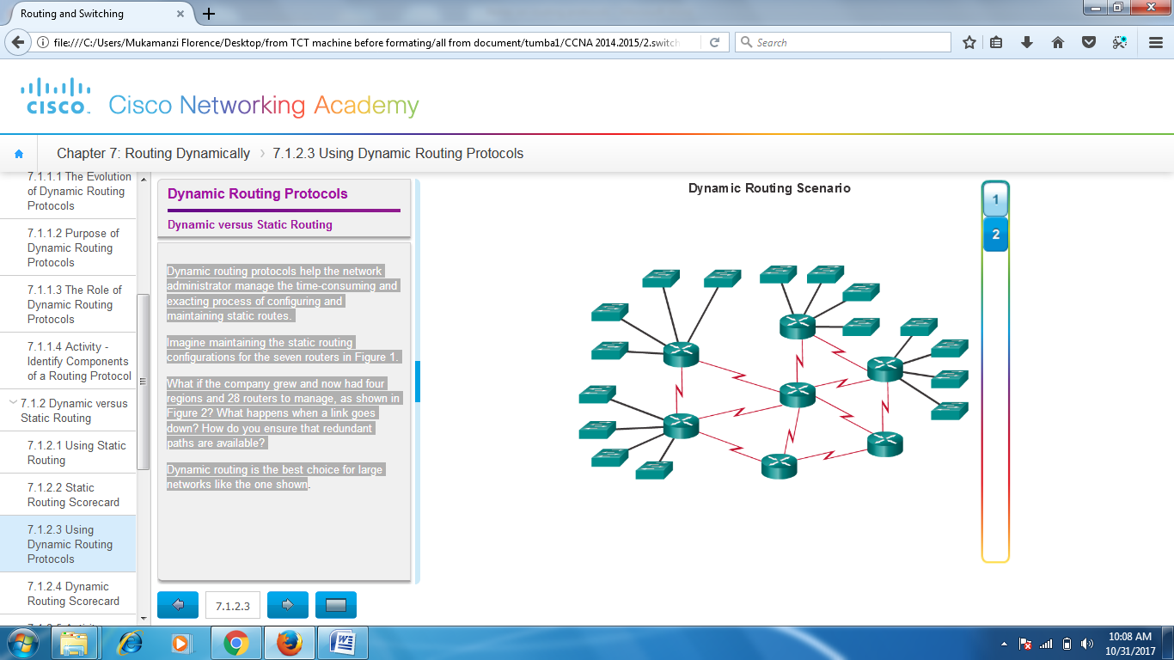

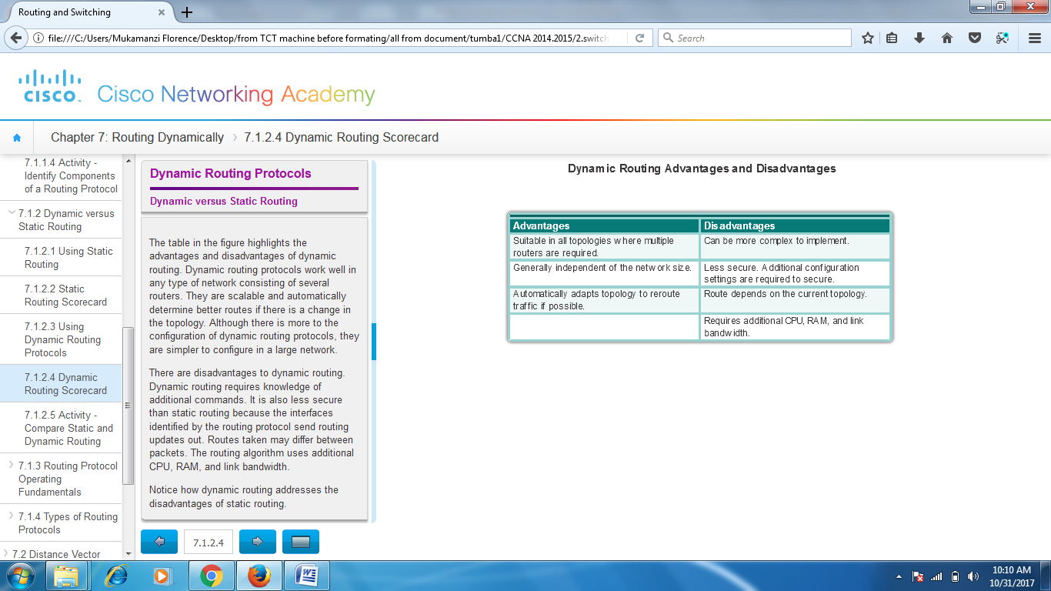

**Types of Routing Protocols**

Routing protocols can be classified into different groups according to their characteristics. Specifically, routing protocols can be classified by their:

* **Purpose** - Interior Gateway Protocol (IGP) or Exterior Gateway Protocol (EGP)
* **Operation** - Distance vector, link-state protocol, or path-vector protocol
* **Behavior** - Glassful (legacy) or classless protocol

For example, IPv4 routing protocols are classified as follows:

* **RIPv1 (legacy)** - IGP, distance vector, classful protocol
* **IGRP (legacy)** - IGP, distance vector, classful protocol developed by Cisco (deprecated from 12.2 IOS and later)
* **RIPv2** - IGP, distance vector, classless protocol
* **EIGRP** - IGP, distance vector, classless protocol developed by Cisco
* **OSPF** - IGP, link-state, classless protocol
* **IS-IS** - IGP, link-state, classless protocol
* **BGP** - EGP, path-vector, classless protocol

The classful routing protocols, RIPv1 and IGRP, are legacy protocols and are only used in older networks. These routing protocols have evolved into the classless routing protocols, RIPv2 and EIGRP, respectively. Link-state routing protocols are classless by nature.

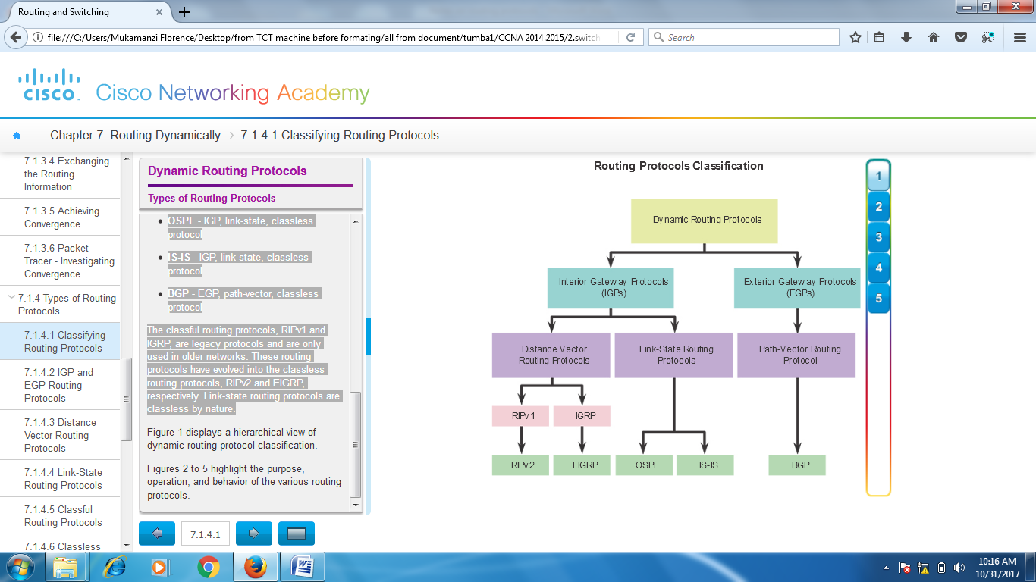

An autonomous system (AS) is a collection of routers under a common administration such as a company or an organization. An AS is also known as a routing domain. Typical examples of an AS are a company’s internal network and an ISP’s network.

The Internet is based on the AS concept; therefore, two types of routing protocols are required:

* **Interior Gateway Protocols (IGP)** - Used for routing within an AS. It is also referred to as intra-AS routing. Companies, organizations, and even service providers use an IGP on their internal networks. IGPs include RIP, EIGRP, OSPF, and IS-IS.
* **Exterior Gateway Protocols (EGP)** - Used for routing between AS. It is also referred to as inter-AS routing. Service providers and large companies may interconnect using an EGP. The Border Gateway Protocol (BGP) is the only currently-viable EGP and is the official routing protocol used by the Internet.

**Note**: Because BGP is the only EGP available, the term EGP is rarely used; instead, most engineers simply refer to BGP.

The example in the figure provides simple scenarios highlighting the deployment of IGPs, BGP, and static routing:

* **ISP-1** - This is an AS and it uses IS-IS as the IGP. It interconnects with other autonomous systems and service providers using BGP to explicitly control how traffic is routed.
* **ISP-2** - This is an AS and it uses OSPF as the IGP. It interconnects with other autonomous systems and service providers using BGP to explicitly control how traffic is routed.
* **AS-1** - This is a large organization and it uses EIGRP as the IGP. Because it is multihomed (i.e., connects to two different service providers), it uses BGP to explicitly control how traffic enters and leaves the AS.
* **AS-2** - This is a medium-sized organization and it uses OSPF as the IGP. It is also multihomed; therefore, it uses BGP to explicitly control how traffic enters and leaves the AS.
* **AS-3** - This is a small organization with older routers within the AS; it uses RIP as the IGP. BGP is not required because it is single-homed (i.e., connects to one service provider). Instead, static routing is implemented between the AS and the service provider.

**Note**: BGP is beyond the scope of this course and is not discussed in detail.

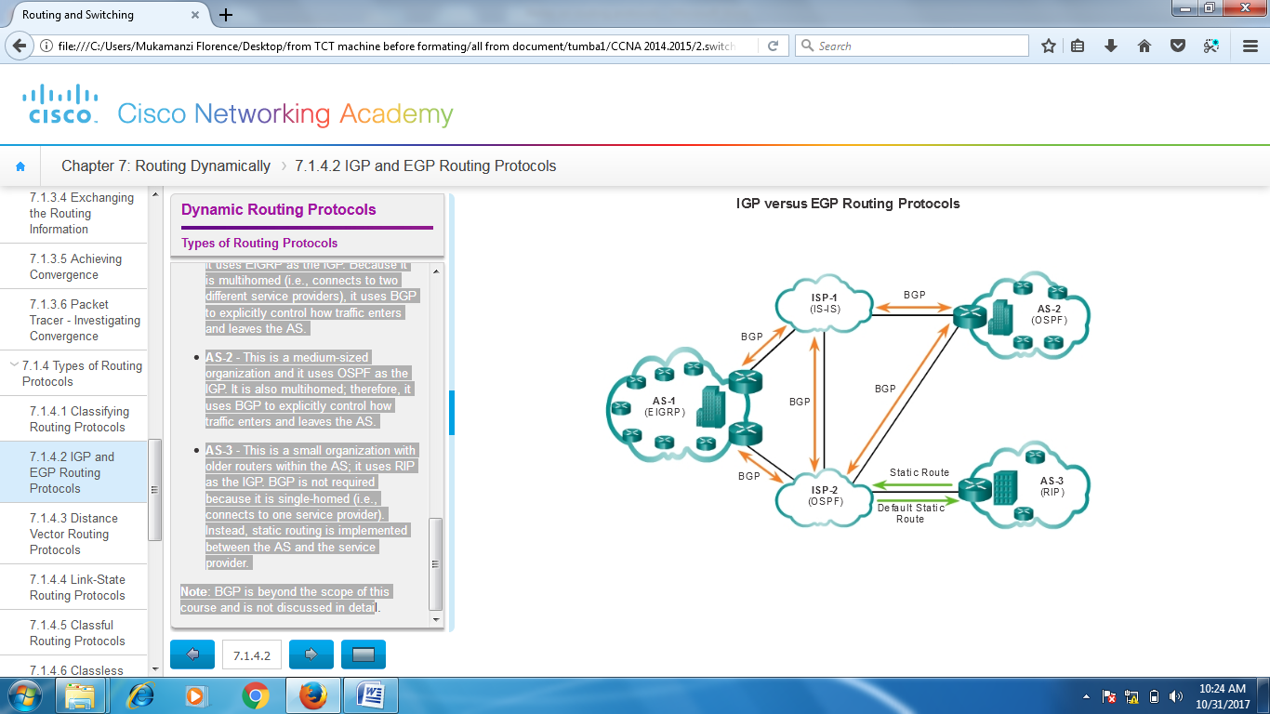

**DISTANCE VECTOR**

**Distance vector** means that routes are advertised by providing two characteristics:

* **Distance** - Identifies how far it is to the destination network and is based on a metric such as the hop count, cost, bandwidth, delay, and more.
* **Vector** - Specifies the direction of the next-hop router or exit interface to reach the destination.

For example, in the figure, R1 knows that the distance to reach network 172.16.3.0/24 is one hop and that the direction is out of the interface S0/0/0 toward R2.

A router using a distance vector routing protocol does not have the knowledge of the entire path to a destination network. Distance vector protocols use routers as sign posts along the path to the final destination. The only information a router knows about a remote network is the distance or metric to reach that network and which path or interface to use to get there. Distance vector routing protocols do not have an actual map of the network topology.

There are four distance vector IPv4 IGPs:

* **RIPv1** - First generation legacy protocol
* **RIPv2** - Simple distance vector routing protocol
* **IGRP** - First generation Cisco proprietary protocol (obsolete and replaced by EIGRP)
* **EIGRP** - Advanced version of distance vector routing

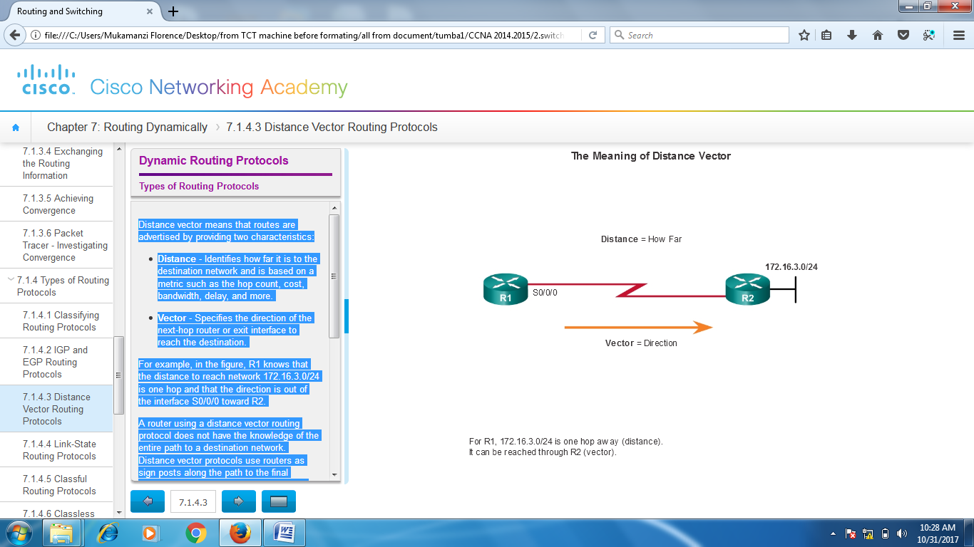

**LINK-STATE**

In contrast to distance vector routing protocol operation, a router configured with a link-state routing protocol can create a complete view or topology of the network by gathering information from all of the other routers.

To continue our analogy of sign posts, using a link-state routing protocol is like having a complete map of the network topology. The sign posts along the way from source to destination are not necessary, because all link-state routers are using an identical map of the network. A link-state router uses the link-state information to create a topology map and to select the best path to all destination networks in the topology.

RIP-enabled routers send periodic updates of their routing information to their neighbors. Link-state routing protocols do not use periodic updates. After the network has converged, a link-state update is only sent when there is a change in the topology. For example, the link-state update in the animation is not sent until the 172.16.3.0 network goes down.

**Link-state protocols work best in situations where:**

* The network design is hierarchical, usually occurring in large networks
* Fast convergence of the network is crucial
* The administrators have good knowledge of the implemented link-state routing protocol

**There are two link-state IPv4 IGPs:**

* **OSPF** - Popular standards based routing protocol
* **IS-IS** - Popular in provider networks

**RIPv2 protocol**

